**GIMNASIO LOS PIRINEOS**

**“EDUCACIÓN Y FORMACIÓN INTEGRAL CON ENFASIS EN VALORES, INGLÉS, EMPRENDIMIENTO Y GESTIÓN LABORAL”.**

**EVALUACION PERIODICA ACUMULATIVA**

**INGLÉS- GRADO SÉPTIMO**

ESTUDIANTE: __________________________________ FECHA: __________________

Reading skill

Write the actions under the correct places.

**Watch your favourite sports team. Buy some local crafts. Try some local foods. Watch the latest blockbuster from Hollywood. See a film with your favourite actor/actress. Register before you enter. Sing songs with other fans. Wear a sports kit. See a play. Watch a musical.**

|  |  |  |  |  |
| --- | --- | --- | --- | --- |
|  |  |  |  |  |
|  |  |  |  |  |
|  |  |  |  |  |
|  |  |  |  |  |

|  |  |  |  |  |
| --- | --- | --- | --- | --- |
| At the sport stadium | At the cinema | At the theatre | At the market | Competing in a sport event |
|  |  |  |  |  |
|  |  |  |  |  |

2. Look and read the adverts

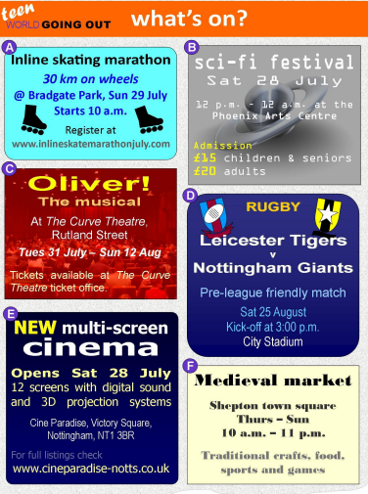

3.Read the questions and write the correct advert (A–F).

1. In which advert can you see actors and actresses performing on stage? In advert …………

2. In which advert must you register online first? In advert …………

3. In which advert does the event finish at midnight? In advert …………

4. In which advert can you see two professional sports teams? In advert …………

5. In which advert can you see the latest Hollywood movie? In advert …………

6. In which advert can you learn about the culture and customs of people many

years ago? In advert …………

7. In which advert do you need a special kind of shoes? In advert …………

8. In which advert do people over the age of 65 pay less to enter? In advert …………

4.Circle True or False for these sentences.

1. The musical performance of Oliver! starts in August. **True False**

2. The medieval market in Shepton town square is closed on Sunday. **True False**

3. The rugby match starts at 3:00 p.m. **True False**

4. You have to register for the inline skating marathon online. **True False**

5. The sci-fi festival runs for one day. **True False**

6. You can eat traditional food at the medieval market. **True False**

7. Tickets for the musical performance of Oliver! can be booked by phone. **True False**

8. The sci-fi festival is on the same day as the new cinema opening. **True False**

5. Write:

**What do you like to do when you go out?**

**_________________________________________________________________________________________________________________________________________________________________________________________________________________________________________________________________________________________________________________________________________________________________________________________________________________**

What are they good at?

In Bert’s family, all the members are good at something and not so good at other things. Ask him about their abilities.Example : Is your cousin good at swimming? – No, he isn’t

gym – no

cook - yes

tennis – yes

ski - no

English – yes

French - no

teach – yes

make cake - no

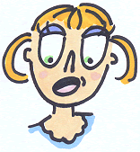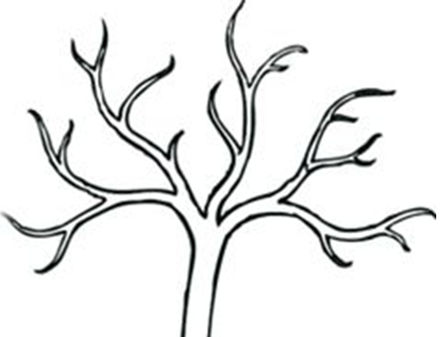

volley – yes

ride bike - no

Math – yes

History - no

swim - no

football - yes

BERT

write – yes

read - no

What can they do?What can't they do?

|  |  |  |  |  |
| --- | --- | --- | --- | --- |
|  |  |  |  |  |
| Bill is down. He  .............................. | They made a goal. They....................... | She makes clothes.  She.......................... | I fell because I  ............................. | Dad made this.He.................. |
|  |  |  |  |  |
| He is a bad student.He..........  .............................. | He is drowning. He  ............................ | We prepare dinner.  We........................ | He is tired. He  ............................ | He is nervous. He  ........................... |